**Linux Administration Essentials**

**Assignment Day 3**

**Question 1**

1. **Create a blank file named "myfile”**

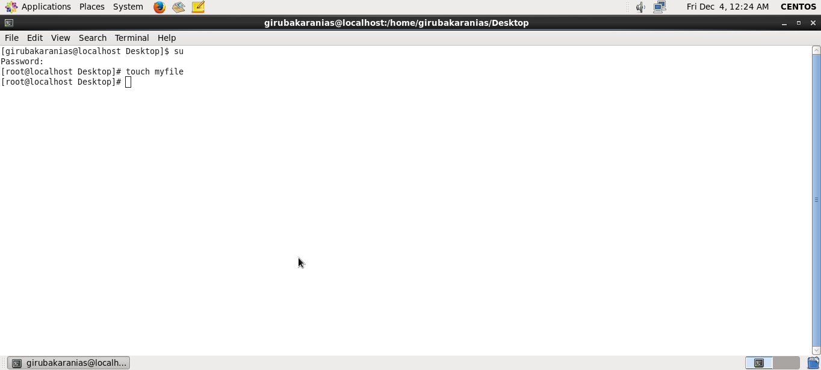

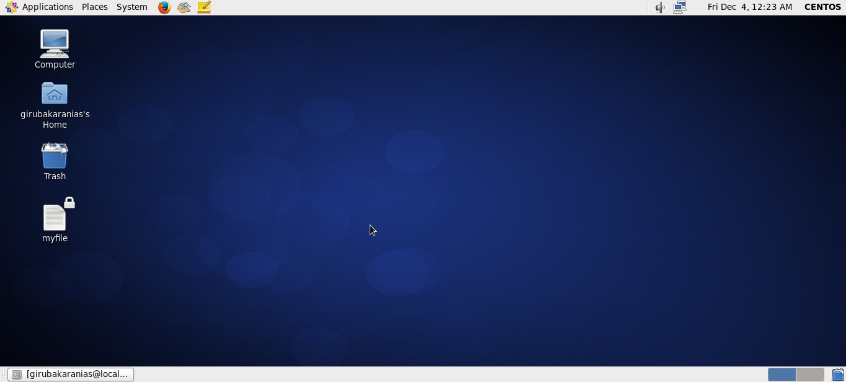

1. **Open "myfile" in vi editor**

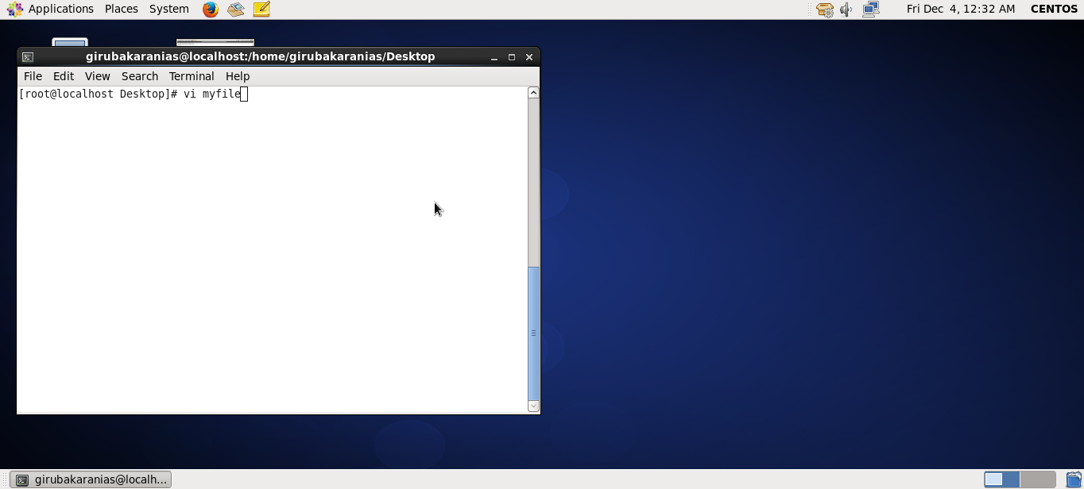

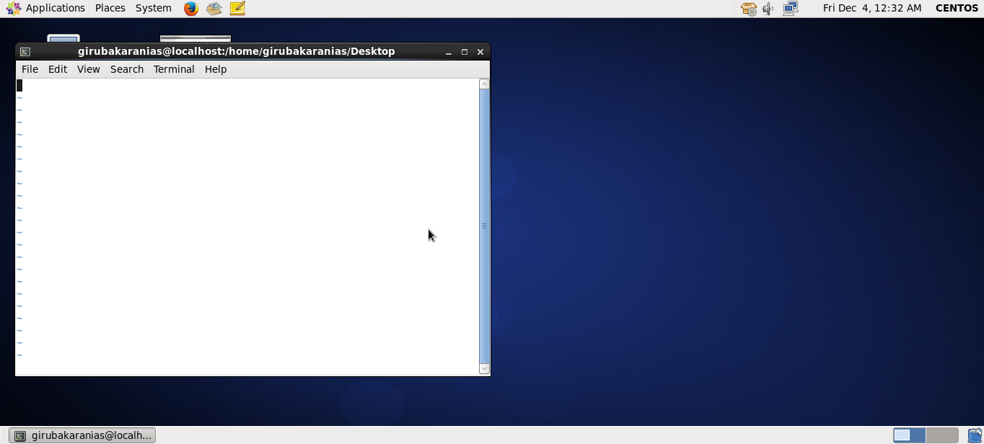

**3. Write your name, address, email id, phone number and blood group in 5 different lines**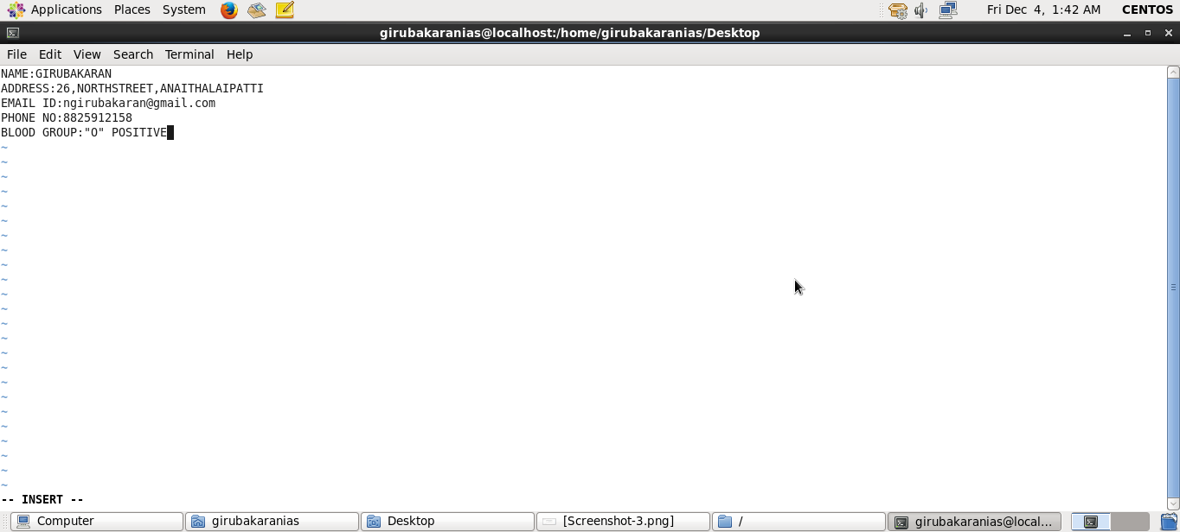

**4. Build one single expression to see the line with your name and blood group in myfile**

